JOB INTERVIEW BLUEPRINT
A Complete Professional Process for Interview Preparation,
Performance, Follow-Up & Offers

TEMPLATE NOTICE
The templates in this blueprint are starting points, not scripts. Change them into your own words, use details from your actual conversation, and keep your natural voice. Never invent experience, results, competing offers, or information that did not happen.

Contents
The Whole System at a Glance
The Complete Job Search Journey
How to Use This Blueprint
Part 1 — The Interviewer's Three Questions
Part 2 — The Master Interview Stack
Part 3 — STAR
Part 4 — STAR-R
Part 5 — The I vs. We Rule
Part 6 — VALUE
Part 7 — Tell Me About Yourself
Part 8 — Why This Role?
Part 9 — Why Should We Hire You?
Part 10 — When You Don't Know
Part 11 — Failure Questions
Part 12 — Technical Reasoning
Part 13 — Incident / Security Scenarios
Part 14 — Resume-to-Interview Alignment
Part 15 — The Follow-Up Question Trap
Part 16 — Story Bank
Part 17 — Research Before the Interview
Part 18 — Questions to Ask
Part 19 — Pre-Interview One-Page Cheat Sheet
Part 20 — Interview-Day Behavior
Part 21 — After the Interview: Document First
Part 22 — Thank-You Email
Part 23 — If You Forgot Something Important
Part 24 — Ask for the Next-Step Timeline
Part 25 — Follow-Up When the Timeline Passes
Part 26 — If You Hear Nothing
Part 27 — Final Follow-Up
Part 28 — Multiple Interviewers
Part 29 — Negotiating an Offer
Part 30 — Offer Confirmation
Part 31 — Rejection Response
Part 32 — What Not to Do
Part 33 — Complete Process
Part 34 — Quick Reference
Part 35 — Template Rule
Part 36 — The Follow-Up Formula
Part 37 — Getting Through AI and ATS Screening
Part 38 — The “Bypass” Tricks, and Why They Backfire
Part 39 — Cover Letter Framework
Part 40 — Researching Your Market Rate
Part 41 — Discover the Opportunity
Part 42 — Research Before You Apply
Part 43 — Identify Your Resources & Connections
Part 44 — Pre-Application Strategy: Is This Actually a Fit?
Part 45 — Applying
Part 46 — Pre-Interview Visibility: Don't Wait for the System to Find You
Part 47 — The Waiting Period
Part 48 — After the Outcome: Transition or Continue
More From Wake Up X

The Whole System at a Glance
Every part of this blueprint sits somewhere on this map. If you ever lose the thread, come back to this page.
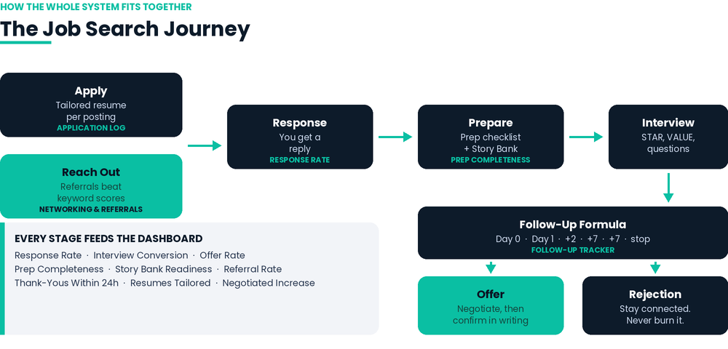
The job search journey, and which tracker tab covers each stage.

The Complete Job Search Journey
The map in "The Whole System at a Glance" shows the interview-day core. Here is the full journey, start to finish, with the Part that covers each stage.
DISCOVER → Find the opportunity. Part 41.
RESEARCH → Research the company, role, team, and hiring manager. Part 42.
IDENTIFY CONNECTIONS → Find anyone you legitimately know there. Part 43.
PRE-APPLICATION STRATEGY → Confirm it's actually a fit before you spend the effort. Part 44.
APPLY → Tailor it, submit it, log it. Part 45.
PRE-INTERVIEW VISIBILITY → Make a real connection aware you applied, if you have one. Part 46.
WAIT / MONITOR → Stay patient, stay in motion. Part 47.
INTERVIEW PREP → Research, story bank, cheat sheet. Parts 14–19.
INTERVIEW → Answer, listen, ask questions. Parts 1–13 and 20.
DOCUMENT → Capture it immediately, while it's fresh. Part 21.
THANK-YOU & FOLLOW-UP → Timed by the follow-up formula. Parts 22–27 and 36.
OFFER OR REJECTION → the path splits here.
- Offer: negotiate → confirm in writing → accept → transition. Parts 29, 30, 48.
- Rejection: respond → preserve the relationship → learn → continue the search. Parts 31, 48.
Rule: this is one connected system, not five separate documents. Whatever phase you're in, this page tells you which Part to open next.

How to Use This Blueprint
This is a general, industry-neutral interview blueprint. It is not limited to cybersecurity or any specific profession.
The goal is to replace memorized answers with a repeatable process: prepare evidence, understand the employer's needs, communicate clearly, handle follow-up questions, ask strong questions, follow up professionally, and handle an offer or rejection.
Core principle: do not memorize dozens of answers. Build evidence and understand your stories deeply enough to adapt them.
Where to start
- First time reading? Read Parts 1-10. That is the core of how to answer well.
- Interview booked this week? Read Part 17 (research), Part 19 (cheat sheet), and Part 18 (questions to ask).
- Just finished an interview? Go straight to Parts 21-24.
- Waiting to hear back? Parts 25-27.
- Got an offer, or a rejection? Parts 29-31.
- Applying and hearing nothing back? Parts 37-38 cover AI and ATS screening.
- Not sure when to chase a reply? Part 36 is the timing formula.
- Writing a cover letter? Part 39.
- Preparing to negotiate? Part 40, then Part 29.
- Found a role today? Start at Part 41 and work forward through Part 45.
- Have any connection to the company? Part 43, then Part 46.
- Applied and waiting to hear back? Part 47.
- Accepted an offer, or continuing your search after a rejection? Part 48.
The companion Job Interview KPI Master Form (Excel) turns all of this into a tracker you fill in as you go.

Part 1 — The Interviewer's Three Questions
- Can you do the work? Demonstrate this with evidence, projects, examples, skills, and specific results.
- Will you be a problem? Demonstrate professionalism, accountability, communication, judgment, teamwork, and how you discuss mistakes and past workplaces.
- Will you still be here in eighteen months? Demonstrate genuine, specific interest in this role rather than simply wanting any job.

Part 2 — The Master Interview Stack
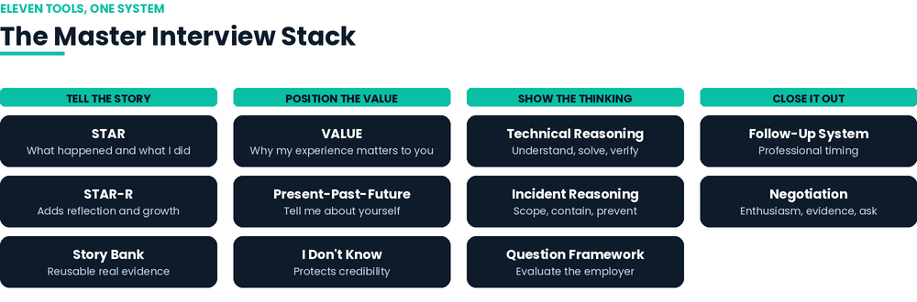
The eleven frameworks in this blueprint, grouped by what they do.
- STAR — tells the story.
- STAR-R — adds reflection when the question calls for learning or growth.
- VALUE — positions your value.
- Present → Past → Future — answers “Tell me about yourself.”
- Technical Reasoning — demonstrates how you solve technical problems.
- Incident Reasoning — structures security/incident scenarios when applicable.
- I Don't Know — protects credibility.
- Story Bank — supplies reusable evidence.
- Question Framework — helps you evaluate the employer.
- Follow-Up System — keeps communication professional and timely.
- Negotiation Framework — helps you handle an offer.

Part 3 — STAR
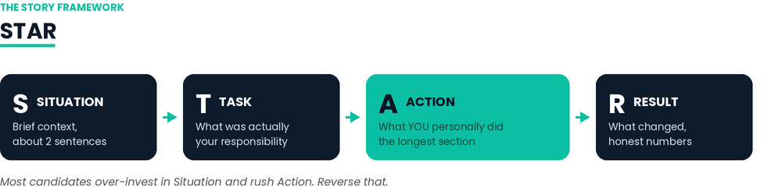
- S — Situation: brief context; roughly two sentences.
- T — Task: what was actually your responsibility?
- A — Action: what did you personally do? This should be the longest section. Use “I” for your contribution.
- R — Result: what changed? Use honest numbers when available; otherwise describe the outcome honestly.
Rule: most candidates over-invest in Situation and rush Action. Reverse that. The interviewer wants your decisions, judgment, and contribution.

Part 4 — STAR-R
For failure, leadership, conflict, growth, and learning questions, add Reflection after Result.
Reflection asks: What did you learn? What changed in your process, judgment, or behavior? What would you do differently next time?
Do not force every answer into five parts. Use reflection when it adds evidence of maturity or changed behavior.

Part 5 — The I vs. We Rule
Use “we” for team context. Use “I” for your decisions, actions, technical work, and contribution.
Example: “Our team needed better visibility. I deployed the solution, tuned the configuration, analyzed the results, and documented the changes.”
Excessive “we” can make it impossible for an interviewer to determine what you actually did.

Part 6 — VALUE
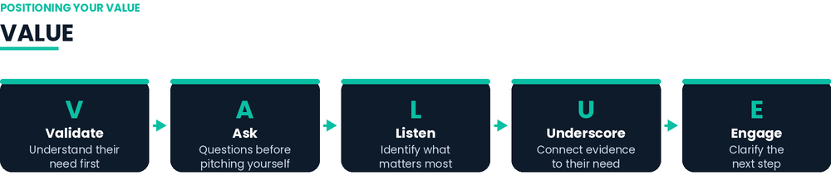
- V — Validate: understand the other person's need before making your case.
- A — Ask: ask questions before pitching yourself.
- L — Listen: identify what matters most.
- U — Underscore: connect your evidence directly to what matters; specifics beat adjectives.
- E — Engage: clarify the next step.
STAR answers “What happened and what did I do?” VALUE answers “Why does my experience matter to you?”

Part 7 — Tell Me About Yourself
Use Present → Past → Future.
- Present: where are you now?
- Past: what experiences prepared you?
- Future: why this role and where can you contribute?
Keep it focused. This is a professional narrative, not a biography.

Part 8 — Why This Role?
Use: genuine reason → relevant evidence → fit with the team/problem → contribution.
Avoid generic statements such as “I need a job,” “I want to grow,” or “I like your company.” Explain why this role, this team, and this problem.

Part 9 — Why Should We Hire You?
Use: Their Need → Your Evidence → Expected Impact.
“From our conversation, it sounds like you need someone who can ______. My background gives me evidence in ______. I believe I can contribute by ______.”
Do not rely on adjectives like hardworking, passionate, or motivated without evidence.

Part 10 — When You Don't Know
“I haven't worked with that directly. Here's what I do know that's adjacent, and here's exactly how I'd go about finding the answer.”
This demonstrates honesty, self-awareness, adjacent knowledge, and method.
Never bluff. One technical bluff can cause the interviewer to question the rest of your claims.

Part 11 — Failure Questions
- Choose a real, bounded failure.
- Own your responsibility plainly.
- Do not distribute blame.
- Spend most of the answer on what you did about it and what changed afterward.
- Avoid the disguised-strength answer such as “I care too much.”
Framework: What happened → What was my responsibility → What did I do → What changed → What changed about my process afterward.

Part 12 — Technical Reasoning
Understand → Break Down → Solve → Verify → Communicate.
- Understand the symptoms, scope, users, systems, timing, and constraints.
- Break down likely causes and separate facts from assumptions.
- Solve by explaining what you would investigate or change and why.
- Verify how you would know the solution worked.
- Communicate what you would document, who needs to know, and what comes next.
The goal is disciplined reasoning, not instantly guessing an answer.

Part 13 — Incident / Security Scenarios
When relevant, use: Scope → Prioritize → Investigate → Contain → Resolve → Document → Prevent.
- Scope: affected systems, identities, devices, data, or users.
- Prioritize: risk, business impact, and urgency.
- Investigate: evidence needed.
- Contain: action that limits further damage.
- Resolve: restore secure operations.
- Document: evidence, decisions, timeline, and outcome.
- Prevent: control, process, detection, training, architecture, or monitoring improvements.

Part 14 — Resume-to-Interview Alignment
Every important resume bullet should survive a two-minute explanation and follow-up questions.
For each bullet prepare: Claim → Evidence → Action → Result → Likely Follow-Up.
Never inflate lab, volunteer, project, or simulated experience into production experience.
If you cannot defend a bullet under follow-up, rewrite it, qualify it, or remove it.

Part 15 — The Follow-Up Question Trap
“Tell me about a project you built” can be the beginning, not the real test.
Prepare for: Why did you choose that approach? What went wrong? How did you troubleshoot it? What would you change? What was your contribution? How would you scale it?
Rule: do not prepare only answers. Prepare depth.

Part 16 — Story Bank
Build 6–10 real stories that can be adapted to multiple questions.
Recommended categories:
- Technical problem
- Failure
- Difficult person
- Team conflict
- Leadership without authority
- Customer/user problem
- Project you are proud of
- Major change
- Learning something difficult
- Incident/security example when relevant
For each story record: Situation, Task, Actions, Result, lesson, metrics, tools, exact contribution, and two hard follow-up questions.

Part 17 — Research Before the Interview
Research five things: company, role, team, interviewer, and the problem the organization is trying to solve.
Research should improve your questions and examples. It should not become a performance.

Part 18 — Questions to Ask
- Role: “What does the first 90 days look like for whoever takes this role?”
- Problem: “What is the thing this team is most frustrated by right now?”
- Prioritization: “How does this team decide what to work on?”
- Performance: “What separates someone who does well here from someone who struggles?”
- Context: “Is this a new role or a backfill?”
- Operations: “How does the team handle it when something goes wrong?”
- Improvement: “What is something you'd change about how this team works?”
Use judgment about when to discuss compensation, vacation, remote work, and other benefits. Early interviews are usually better spent understanding the work and team.

Part 19 — Pre-Interview One-Page Cheat Sheet
Company: ______________________________
Role: __________________________________
Interviewers: __________________________
Top 3 problems this role appears to solve: 1) ______ 2) ______ 3) ______
Why this role: __________________________
My 3 strongest proof points: 1) ______ 2) ______ 3) ______
STAR stories: Technical ______ | Conflict ______ | Failure ______ | Leadership ______ | Customer ______
Technologies/skills I know: _____________________
Knowledge gaps + honest response: ______________
Five questions I will ask: 1) ______ 2) ______ 3) ______ 4) ______ 5) ______

Part 20 — Interview-Day Behavior
- Answer the question that was asked. Do not ramble to fill silence.
- Do not criticize former employers, managers, or colleagues.
- Do not rely on memorized scripts.
- Practice out loud. Record yourself when possible.
- Use “I don't know” honestly when appropriate, followed by adjacent knowledge and your method.
- Clarify next steps before the interview ends.

Part 21 — After the Interview: Document First
Immediately after the interview, record: interviewer names; topics discussed; problems they described; examples you gave; questions you asked; anything you promised to send; anything you wish you had explained better; and the stated next-step timeline.
This information makes your follow-up personalized and prevents you from relying on memory.

Part 22 — Thank-You Email
Recommended timing: same day or within 24 hours.
Subject: Thank You for Your Time — [Position]

Hi [Name],

Thank you for taking the time to speak with me about the [Position] role.

I really enjoyed learning more about [specific topic], particularly your perspective on [specific detail].

Our conversation reinforced my interest in the position, especially because [specific reason connected to the role/team].

I believe my experience with [relevant skill/experience] could allow me to contribute to [specific problem or goal discussed].

Thank you again for your time and consideration. Please let me know if I can provide any additional information.

Best,
[Name]

Part 23 — If You Forgot Something Important
Use this only when you genuinely missed a relevant qualification, example, or answer.
Subject: Follow-Up — [Position]

Hi [Name],

Thank you again for speaking with me today.

After reflecting on our conversation, I realized there was one relevant example I didn't have an opportunity to fully explain.

When I was [situation], I [action], which resulted in [result].

I thought this example was particularly relevant because we discussed [specific responsibility/problem].

I appreciate your time and consideration.

Best,
[Name]
Rule: add value; do not apologize excessively.

Part 24 — Ask for the Next-Step Timeline
“What should I expect as the next step, and what does your timeline look like from here?”
Write the timeline down. If they say next Friday, use next Friday as your reference point.

Part 25 — Follow-Up When the Timeline Passes
Subject: Follow-Up — [Position]

Hi [Name],

I wanted to follow up regarding the [Position] role. When we spoke, you mentioned that you expected to have an update around [date/timeframe], so I wanted to check in.

I'm still very interested in the opportunity, particularly because [specific reason].

Please let me know if there are any updates or if there's anything else I can provide.

Thank you again for your time.

Best,
[Name]

Part 26 — If You Hear Nothing
If the stated timeline has passed, send a polite status message. Do not assume silence automatically means rejection.
Subject: Checking In — [Position]

Hi [Name],

I wanted to check in regarding the [Position] opportunity.

I remain very interested in the role and enjoyed learning more about [team/topic].

I understand hiring timelines can change, so I wanted to see whether there have been any updates regarding the position or next steps.

I'm happy to provide anything else that would be helpful.

Thank you,
[Name]

Part 27 — Final Follow-Up
Use a final check-in when you have already sent the thank-you and a reasonable status follow-up.
Subject: Final Follow-Up — [Position]

Hi [Name],

I wanted to reach out one final time regarding the [Position] opportunity.

I remain interested in the position and appreciated the opportunity to learn more about the team.

I understand priorities and hiring timelines can change. If the position is still active, I'd be happy to remain in consideration. If the role has been filled or the search has changed direction, I appreciate the update as well.

Thank you again for your time.

Best,
[Name]

Part 28 — Multiple Interviewers
Personalize whenever possible.
- Hiring manager: focus on role, team, expectations, and business problems.
- Technical interviewer: reference the technical discussion.
- Potential teammate: reference the team's work or collaboration.
Do not send an identical mass email that feels automated.

Part 29 — Negotiating an Offer
Use Enthusiasm → Evidence → Ask.
“I'm very excited about the opportunity and the team. Based on the responsibilities of the position and my experience with [relevant evidence], I was hoping there might be some flexibility on the base salary. Is there room to move toward [$X]?”
Do not imply a competing offer you do not have.
Possible levers may include base salary, bonus, title, certification/training budget, conference attendance, start date, schedule or remote flexibility when supported, equipment, professional development, or an earlier compensation review.
Get material terms in writing.

Part 30 — Offer Confirmation
Subject: Thank You — [Position] Offer

Hi [Name],

Thank you for the offer for the [Position] role.

I'm excited about the opportunity to join [Company] and contribute to [team/area].

As discussed, I understand the following:
Position: [Title]
Salary: [$]
Start date: [Date]
Schedule: [Schedule]
Other agreed terms: [Terms]

Please let me know if I've missed anything or if there is anything else you need from me before my start date.

I'm looking forward to joining the team.

Best,
[Name]

Part 31 — Rejection Response
Never burn the bridge.
Subject: Thank You — [Position]

Hi [Name],

Thank you for letting me know, and thank you again for the opportunity to interview for [Role]. I appreciated learning more about the team and the work.

While I'm disappointed, I enjoyed the conversation and would be glad to stay connected. If a future role opens that aligns with my background, I'd welcome the opportunity to reconnect.

Best,
[Name]

Part 32 — What Not to Do
- Do not send the exact same generic email to everyone.
- Do not send multiple emails in a short period.
- Do not ask “Did I get the job?”
- Do not write an emotional message because you have not heard back.
- Do not apologize repeatedly for an imperfect answer.
- Do not negotiate salary in the thank-you email.
- Do not send a huge wall of text.
- Do not repeatedly call without an invitation.
- Do not follow up before the stated timeline without a legitimate reason.
- Do not assume silence immediately means rejection.

Part 33 — Complete Process
BEFORE: discover the opportunity (Part 41) → research it (Part 42) → identify connections (Part 43) → confirm the fit (Part 44) → apply (Part 45) → create visibility if appropriate (Part 46) → wait and monitor (Part 47) → prepare evidence → prepare story bank → review resume → prepare questions → understand the role.
DURING: answer directly → use evidence → show your contribution → be honest about gaps → demonstrate reasoning → ask strong questions → confirm next steps.
AFTER: document the conversation → send personalized thank-you → wait for the stated timeline → follow up when appropriate → handle offer/rejection professionally → preserve the relationship → transition or continue (Part 48).

Part 34 — Quick Reference
- Thank-you: same day / within 24 hours.
- Forgotten relevant information: only when it genuinely adds value.
- Timeline follow-up: after the employer's stated timeline passes.
- No timeline: use a reasonable professional interval rather than repeatedly checking.
- Multiple interviewers: personalize when possible.
- Pre-interview visibility: only with a legitimate connection, per Part 46 — never a substitute for a real application.
- Offer: review, negotiate professionally if appropriate, and confirm material terms in writing.
- Rejection: thank them, preserve the relationship, and remain professional.
Always: specific > generic; concise > long; authentic > scripted; evidence > adjectives; honesty > bluffing; depth > memorization.

Part 35 — Template Rule
Every email in this blueprint is a template.
CHANGE IT IN YOUR OWN WORDS.
Use the structure, then replace the placeholders with what actually happened. If a sentence does not sound like you, rewrite it. If a detail is not true, remove it.
The best follow-up email does not look like a template. It looks like a thoughtful message written by a real person who paid attention.

Part 36 — The Follow-Up Formula
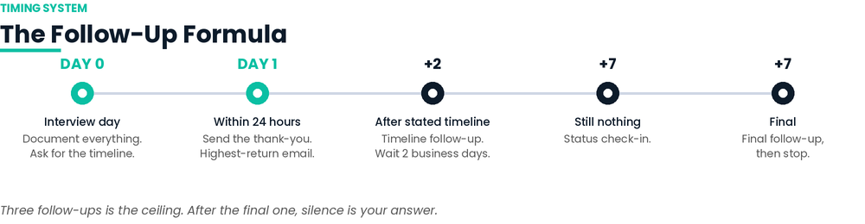
Parts 22-27 give you the individual emails. This is the timing system that tells you which one to send and when, so you are never guessing.
The formula: Day 0 -> Day 1 -> Stated Timeline + 2 -> +7 -> Close.
- Day 0 (interview day): document everything while it is fresh, per Part 21. Ask for the timeline before you leave, per Part 24.
- Day 1 (within 24 hours): send the thank-you, per Part 22. This is the single highest-return follow-up you will send.
- Stated timeline + 2 business days: if they said 'by Friday' and Friday passes, wait two business days, then send the timeline follow-up, per Part 25.
- +7 days after that: if still nothing, send the status check-in, per Part 26.
- +7 days after that: send the final follow-up, per Part 27. Then stop, and move the role to 'closed' in your tracker.
If no timeline was given, substitute one week from the interview for the first follow-up, then keep the same seven-day spacing.
Two rules that matter more than the wording:
- Never follow up before the stated timeline without a real reason. A new certification, another offer, or a genuine question counts. Anxiety does not.
- Three follow-ups is the ceiling. After the final one, silence is your answer. Keep the relationship warm and put your energy into live opportunities.
The value-add variation
A follow-up that carries something useful outperforms one that only asks for news. If you have something real to send, use this instead of the standard check-in.
Subject: Follow-Up — [Position]

Hi [Name],

Following up on the [Position] role. Since we spoke, I [finished the certification / built the project / read the thing you mentioned], which connects directly to the [specific problem] you described.

[One sentence on what you learned or built, and why it is relevant to their problem.]

Still very interested. Happy to send anything else that would be useful.

Best,
[Name]
Do not manufacture a reason. If you have nothing new, the plain check-in in Part 26 is the better email.

Part 37 — Getting Through AI and ATS Screening
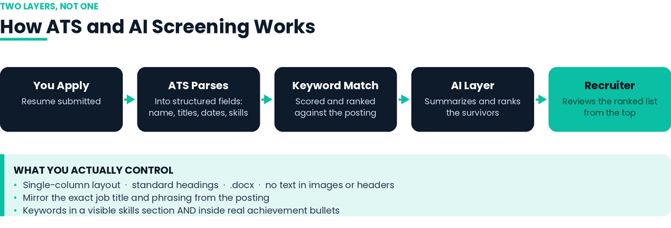
Most applications are read by software before a person sees them. Understanding what that software actually does is worth more than any trick.
What is actually happening
There are now two layers. First, the applicant tracking system parses your resume into structured fields: name, contact details, job titles, dates, education, skills. Then it scores and ranks you against the job description, weighted heavily toward keyword matching. On top of that, a newer AI layer increasingly summarizes and ranks whoever survives the first pass.
The important correction: the ATS is mostly a routing and ranking tool, not an execution chamber. In one 2026 survey of US recruiters, the large majority said their system does not auto-reject for formatting or missing keywords. The far more common reason you hear nothing is volume. Hundreds of people apply, a recruiter reviews from the top of a ranked list, and your job is to be high enough on that list to get read.
Make the file machine-readable
- Single-column layout. Multi-column resumes are the most common parsing failure, because the parser reads across columns and scrambles your content.
- Standard section headings: Experience, Education, Skills, Certifications. Creative headings do not map to the fields the parser expects.
- No text inside images, text boxes, headers, or footers. Parsers routinely miss all of these. Put your contact details in the body of the document.
- Use .docx unless the posting specifies otherwise. It is the most reliably parsed format.
- Spell out an acronym and pair it with the full term at least once: 'Security Information and Event Management (SIEM)'. The posting may search for either one.
- Standard date formats, consistent throughout. Broken dates produce broken employment history.
Use the right keywords, in the right places
- Mirror the exact job title from the posting. If they wrote 'Security Analyst' and you wrote 'Cybersecurity Specialist', you are competing at a disadvantage for no reason. This is the highest-leverage single change you can make.
- Use the posting's exact phrasing, not your preferred synonym. If they say 'incident response', do not write 'threat handling' and expect credit for it.
- Put the highest-value terms in your summary and most recent role, not buried at the bottom.
- Add a visible Core Competencies or Technical Skills section with the genuine skills from the posting. Visible to the software and to the recruiter, which is the point.
- Work keywords into real achievement bullets. Modern AI screeners check whether a claimed skill is supported by your work history. A skill listed with nothing behind it now reads as a weak signal, not a strong one.
- Tailor per application. The same resume sent everywhere is the single biggest cause of low match scores.
The honest limit
Keywords get you screened in. Your actual skills get you hired. Every term you add should be something you can defend under the follow-up questions in Part 15. If you cannot survive a two-minute conversation about it, it does not belong on the resume, per Part 14.

Part 38 — The “Bypass” Tricks, and Why They Backfire
You will see these circulating. They are worth understanding, because the reason they fail tells you what actually works.
The most common one is the white-font trick: paste the job description into your resume in white or size-one font, so the software reads it and the human does not.
Here is what actually happens.
- Parsers strip formatting. Most modern platforms extract raw text, so your invisible block reappears as a visible wall of unrelated keywords at the end of your parsed profile. The recruiter sees it in plain black.
- Several major platforms do not read it at all, so you get no benefit while carrying all of the risk.
- Some systems flag the document outright as suspicious content, or trip a keyword-density check that many systems treat as an automatic disqualifier.
- The reveal is instant when a recruiter pastes your resume into an email or a notes field. At that point you are not a candidate with a formatting quirk. You are someone who tried to deceive them.
- Recruiters talk, especially inside specialized industries. One flagged application can follow you across a network of companies.
Even the most generous published estimate from an industry executive puts the effect of the trick at a small share of the difference between an accepted and rejected resume, and that is before accounting for the downside. The risk-to-reward is bad in both directions.
The deeper problem is what it signals. If you are willing to deceive the system to get an interview, a recruiter has a reasonable question about what else you would be willing to do once hired. That is not a question you can recover from in the room.
The legitimate version of the same goal
Everything the trick is trying to fake, you can do openly:
- Want the software to see the keywords? Put them in a visible skills section and inside real achievement bullets, per Part 37.
- Want to skip the queue entirely? Referrals and direct contact with the hiring manager bypass the ranked list in the way the trick only pretends to. A person forwarding your resume outranks any keyword score.
- Want to know your match before you send? Compare your resume against the posting yourself, line by line, and close the real gaps.
- Not getting callbacks after all of that? The answer is usually a genuine gap, a mismatched target, or a resume that does not show evidence. All three are fixable. None are fixed by hiding text.
The goal is not to trick the software into overstating you. It is to make sure the software does not understate you.

Part 39 — Cover Letter Framework
A cover letter has one job: make the reader want to open the resume with your name already in mind. It is not a summary of the resume and it is not a second copy of it.
Use VALUE, the same structure from Part 6, applied to a page instead of a conversation.
- Validate: open with something specific about the role or the problem the team is solving. Not “I am writing to apply for...”
- Ask (implicitly): show you understand what they need before you talk about yourself.
- Listen: reflect back the one or two things that matter most for this role, in their language, not generic language.
- Underscore: give one or two pieces of real evidence that connect directly to what they need. Specifics beat adjectives here exactly as in Part 9.
- Engage: close by inviting the next step, not by restating that you are excited.
Structure: four short paragraphs, one screen, no more.
Paragraph 1 - Validate: Name the role and one specific thing about the team, problem, or posting that shows you read it closely, not a template opener.

Paragraph 2 - Underscore (their need -> your evidence): 'From the posting, it sounds like you need someone who can [need]. In my work at [company], I [specific action and result].' This is Part 9's structure, reused.

Paragraph 3 - Underscore (second proof point, different skill): one more concrete example. Do not repeat the resume line for line - add the context or result the resume did not have room for.

Paragraph 4 - Engage: 'I would welcome the chance to talk about how I could contribute to [specific team/problem]. Thank you for your consideration.'
Rules that keep it from reading like a template
- Never open with “I am excited to apply.” Everyone opens with that; it tells the reader nothing.
- Name the team, product, or problem specifically. If you cannot name anything specific about this employer, you have not done the Part 17 research yet.
- One page, four paragraphs, no exceptions. A longer letter reads as a first draft, not as respect for the reader's time.
- Do not summarize the resume. Add what the resume could not hold: the reasoning behind a decision, the part of the story a bullet point cannot carry.
- Match the tone of the posting. A formal enterprise posting and a scrappy startup posting should not get the same letter.
Same rule as every template in this blueprint applies here: replace every bracket with something true, in your own words, per Part 35.

Part 40 — Researching Your Market Rate
Part 29 tells you to negotiate. This is how you know what number to negotiate toward, so the ask in Part 29 is grounded instead of a guess.
No single source is reliable alone
Different salary tools pull from different populations and disagree with each other, sometimes by a wide margin for the same title and level. The gap exists because each source collects data differently - self-reported, employer-submitted, or offer-letter-verified - on different timelines. Treat every number as one data point, not a verdict.
Triangulate across at least three source types:
- A large self-reported database (e.g. Glassdoor, LinkedIn Salary) for volume and context - company reviews and sentiment alongside the number.
- A profile-matching tool (e.g. Payscale) that adjusts for your specific years of experience, certifications, and location rather than a flat title average.
- Government wage data (e.g. the U.S. Bureau of Labor Statistics Occupational Employment and Wage Statistics) for a free, non-commercial baseline that is not trying to sell you anything.
- If you are in tech specifically, a verified-offer tool (e.g. Levels.fyi) for total-compensation data at equity-heavy employers - but know its coverage thins out fast outside large tech companies.
What to actually do with the numbers
- Pull a range from each source for the exact title, level, location, and company size - not just the title alone. Seniority and location swing the number more than almost anything else.
- Take the median of what you find, not the highest number you saw. Anchoring to an outlier makes your ask easy to dismiss.
- Ask your network directly. A real number from someone one step removed from the actual role often beats every tool combined, and it is free.
- Re-check before every negotiation, not once at the start of your search. These numbers move, sometimes significantly, over the course of months.
Bring the range, not a single number, into Part 29's negotiation conversation. “Based on my research, this role typically runs [$X-$Y] for this level and location” is a stronger opening than a single guessed figure - it shows you did the work and it gives them room to respond inside a range instead of against a demand.

Part 41 — Discover the Opportunity
This is where the whole system starts. Parts 1–40 assume a posting already exists and an interview is coming. This part, and the seven after it, cover everything before that.
Where roles actually come from
- Job boards and aggregators (LinkedIn, Indeed, industry-specific boards) — fast and high-volume, but also the most competitive channel.
- Company careers pages directly — sometimes posted before, or instead of, appearing on a board.
- Recruiters and staffing firms — common for specialized or senior roles.
- Referrals and your own network — see Part 43. Often the fastest path to an actual conversation.
- Alumni groups and professional associations in your field.
- Direct outreach to a company you want to work for, even before a role is posted.
Rule: the fastest response almost always comes through a person, not a portal. Treat job boards as one channel, not the whole strategy.
- Set up alerts on two or three sources rather than checking manually every day.
- Add your target companies' own careers pages to the rotation — boards can lag behind what a company has already posted.
- The moment something is worth pursuing, add it to the Application Log tab, even before you apply, so it doesn't get lost.

Part 42 — Research Before You Apply
Part 17 covers research right before an interview. This is earlier — research that shapes whether, and how, you apply at all.
Research five things
- Company — mission, recent news, growth or funding, market position.
- Role — responsibilities, seniority, why it's open now.
- Team — who's on it, who they report to.
- Hiring manager or recruiter, if known — background, any shared connection.
- The business problem the role most likely exists to solve.
Purpose: this feeds directly into Part 44's fit check and Part 43's connection list. It is not a performance for the interview — it is decision-making for you, done early.
Where to look
Company site and careers page, LinkedIn (company page and people), recent press or product news, employee review sites for a general read on culture, and the posting itself for language and priority clues.

Part 43 — Identify Your Resources & Connections
Before you apply, take two minutes to ask who you might legitimately know at, or connected to, this company.
- Hiring manager
- Recruiter
- Employee
- Former coworker
- Professional contact
- Referral source
- LinkedIn connection
- Email contact
- Other legitimate professional relationship
Rule: legitimate means an actual professional relationship or a genuine, traceable connection — not a stranger you are about to pretend to know.
Log anyone you identify in the tracker's Networking & Referrals tab as soon as you find them, even before you reach out. This is the list Part 46 draws from.

Part 44 — Pre-Application Strategy: Is This Actually a Fit?
Applying to everything dilutes your energy and your response rate. Before you apply, answer these honestly.
- Is this actually a good-fit role, or does it just sound good?
- What qualifications do I already have for it?
- What real gaps exist — and are they disqualifying, or just something to address per Part 10?
- What keywords matter for this posting? See Part 37.
- What evidence do I have for the claims I'd make? See Part 14.
- Who, from Part 43, could plausibly refer me or make someone aware of my application?
- What do I still need to research before I apply? See Part 42.
Rule: a handful of tailored applications outperforms a large batch of generic ones. This step is what makes real tailoring possible.

Part 45 — Applying
This is the mechanical step — and it's where most of the tracking value gets created or lost.
- Tailor the resume to the posting's language and priorities. See Part 37.
- Write a cover letter when the posting calls for one, or when it meaningfully helps your case. See Part 39.
- Confirm every claim on the resume survives Part 14's test before you submit it.
- Log the application the same day: date, company, role, source, whether you tailored it, and any referral involved.
Rule: log it the same day, every time — even the applications you're not excited about. A missing entry breaks every number downstream on the Dashboard.
If you identified a real connection in Part 43, this is also the moment to plan your next move: Part 46.

Part 46 — Pre-Interview Visibility: Don't Wait for the System to Find You
After you apply, most candidates sit back and wait for the applicant tracking system to surface them. You don't have to. If you have a legitimate professional connection to the hiring manager, someone on the team, a recruiter, an employee, a former coworker, or another professional contact, you can appropriately make that person aware that you applied.
What this is, and what it isn't
The goal: create legitimate human visibility around an application that might otherwise sit inside an ATS queue.
Not the goal: bypass the hiring process, manipulate the recruiter, or demand an interview.
Appropriate channels
- LinkedIn message
- Email
- A referral or a professional introduction through someone else
- Phone or text — only when the relationship and context genuinely make it appropriate
A simple structure to adapt
Hi [Name],

I recently applied for the [Position] role at [Company]. I wanted to reach out because I have a strong interest in the position, and I believe my background in [relevant area] could be a good fit.

I wanted to make sure you were aware of my application. I'd welcome the chance to talk if it's useful, but completely understand if the process needs to run its normal course.

Thanks for your time,
[Name]
Same rule as every template in this blueprint: replace every bracket with something true, in your own words, per Part 35.
Rules
- Be professional. Be concise. Be authentic.
- Don't pressure the person, and don't spam — one message, not a campaign.
- Don't repeatedly contact the same person about the same application.
- Don't ask anyone to violate company policy.
- Don't pretend to have a relationship you don't have.
- Don't exaggerate your qualifications.
- Don't demand that someone forward your resume.
- Don't assume direct contact guarantees an interview.
- Use legitimate relationships appropriately — not as leverage.
How this differs from everything nearby
These get confused with each other. Keep them separate:
- Networking — building relationships over time, not tied to one specific application.
- Referral — someone with standing at the company formally recommends or submits you.
- Direct outreach — reaching out to someone you don't yet know, cold, about an opportunity.
- Pre-interview visibility — making an existing connection aware of an application you've already submitted. Covered here.
- Interview follow-up — communication after you've actually spoken with someone. Parts 22–27.
Rule: this stays out of interview performance. It is not a STAR story, it isn't scored on the cheat sheet, and it has no bearing on how you're evaluated once you're in the room. Track it in the Networking & Referrals tab — not anywhere near your interview prep.

Part 47 — The Waiting Period
Once you've applied — and reached out per Part 46, if you had a legitimate connection — there's a real gap before anything else happens. What you do here matters.
- Track the application status honestly in your log.
- Respect stated timelines before following up — the same patience Parts 24–27 describe for after an interview applies here too.
- Keep applying elsewhere. One application in flight is not a plan.
- Keep networking, per Part 43.
- Keep improving a skill or closing a gap you identified in Part 44.
- Prepare as if the interview could come at any time.
- Follow up when there's a legitimate reason to — not out of anxiety.
Silence does not automatically mean rejection. It also isn't a reason to send five check-ins. Hold both at once.

Part 48 — After the Outcome: Transition or Continue
Parts 29–31 cover the offer and rejection conversations themselves. This is what happens in the days after either one.
If you accepted
- Confirm final terms and start date in writing, per Part 30.
- Confirm what documents or steps are required before day one.
- Ask what to expect in the first week.
- Maintain professionalism with everyone involved in the process — not just your new manager.
- Thank the people who helped: referrals, connections from Part 43, anyone who made you aware of the role or vouched for you.
- Close out your other open applications professionally rather than leaving them hanging.
If you were rejected
- Send the Part 31 response, and mean it.
- Ask to stay connected if the conversation warrants it — LinkedIn, an occasional check-in.
- Ask for feedback when it feels appropriate; not every recruiter can give it, but it costs nothing to ask.
- Ask to be considered for future roles if the fit was close.
- Update the tracker, and note what you'd do differently.
- Keep networking and keep applying — one rejection is a data point, not a verdict.
Rule: rejection is not the end of the system. It runs back into Part 41 and Part 43 — the search continues, and the relationship, where it's worth keeping, continues with it.

More From Wake Up X
This blueprint is one piece of the Wake Up X resource set — practical, no-fluff tools for career growth, cybersecurity, and personal reinvention.
- Quick Start Guide (2-page PDF) — what to open, when, and why. Start here if this is your first time through the bundle.
- Job Interview KPI Master Form (Excel) — a companion tracker: log applications, score your interview prep, build your story bank, track referrals, follow-ups and offers, with a live KPI dashboard.
- Interview Cheat Sheet (printable one-pager) — Part 19, pulled out to carry into the room.
- Story Bank Worksheet (printable) — Part 16, fill-in version for the 10 story categories.
- Six framework diagrams (PNG) — The Job Search Journey, The Master Interview Stack, STAR, VALUE, The Follow-Up Formula, and How ATS Screening Works.
- I Just Have To Wake Up — the founder's memoir on turning adversity into direction.
- Comfort Is Expensive — on breaking out of the comfort zone and building a resilient mindset.
- The Wake Up X Library — DECODE plus nine companion books covering breaking into tech, building your brand, leading without a title, and more.
Find the full library, the podcast, and more free resources at wakeupxpodcast.com.

